TITLE USE FONT TIMES NEW ROMAN 14 BOLD

Author Name^{1*}, Author Name² and Author Name³ Use Font Times New Roman 12 Bold

^{1,2} Department, Institution, City, COUNTRY.
³ Department, Institution, City, COUNTRY.

*Corresponding author: aaa@gmail.my

ABSTRACT

Put your abstract here. Use single spacing. Abstract are written preferably from 100 to 200 words. The abstract should be clear, descriptive and should provide brief information to the problem. This should generally be followed by a statement regarding the methodology and a summary of result. The abstract should end with a comment on the significance of the result or a brief conclusion. Articles should be submitted in English. Put your abstract here. Use single spacing. Abstract are written preferably from 100 to 200 words. The abstract should be clear, descriptive and should provide brief information to the problem. The abstract summarises the major aspects of a paper. It should succinctly summarise the purpose of the paper, the methods used, the major results, and conclusions. Articles should be submitted in English.

Keywords: Maximum of 5 keywords separated by semicolon (;) with Capitalize Each Sentence.

INTRODUCTION

In this section, author should address the following information which is background, problems and objectives of the research. This is a template document which contains the format of extended abstract for ICWR 2025. All submission should strictly follow this format to ensure a consistent, high-quality appearance proceeding. Author can download the template from the conference website (https://utmspace.edu.my/icwr2025/). The easiest way to format your paper exactly like this template document is simply to replace the content with your own material.

Author should follow the following guidelines. The extended abstract should be written in MS Word format in single-spaced in 10-point Times New Roman. Text paragraphs must be justified with no indentation. Each paragraph must be a single-spacing separated. The in-text citation of the manuscript should be in Harvard Referencing Style. According to Islam & Soares (2018) that there is only one space between sentences. Note that there is only one space between sentences (Kong et al. 2019). Text paragraphs must be justified with no indentation as mentioned by Singh et al. (2017).

Please ensure the extended abstract has a maximum of 2 pages, including the references. The extended abstract has to be concise and informative, and comprised of the objective of the study, methodology and the conclusions of the work. All figures or tables should be centred, and caption should be placed under the figure (see Figure 1). Meanwhile, caption for the table should be placed above the table (see Table 1) Page format of the abstract should be in A4 size with a margin of 2.5 cm wide from the right, left, top and bottom. The pages should not be numbered. The incorrect formats may result in your abstract being returned to you by e-mail.

METHODOLOGY

In this section, author should concisely describe and justify the research design choices including methodological approach and limitations, sampling selection, materials, tools and instruments, data collection and analysis methods. The computation of some parameters using Equation (1):

(1)

RESULTS AND DISCUSSION

In this section, author should address the following information which is finding and discussion. Please observe Figure 1 and Table 1 to include figure and table in the extended abstract, respectively. A figure should be inserted like the one below and referred to in the text.

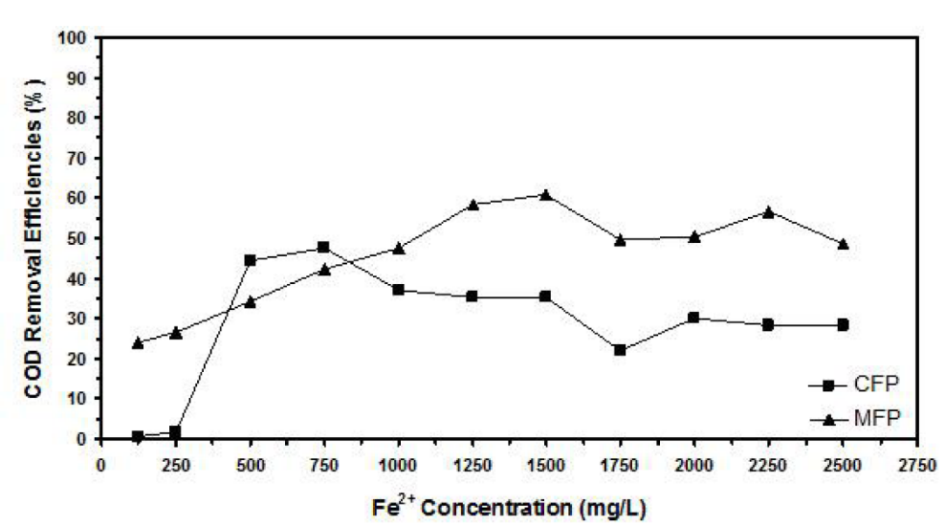
Figure 1. Example of figure for the extended abstract.

A table should be inserted like the one below and referred in the text. Please avoid vertical rules and shading in table cells.

Table 1. Example of table for the extended abstract
Contents of Table

CONCLUSION

The conclusion is intended to help the reader understand why your research should matter to them after they have finished reading the paper. A conclusion is not merely a summary of the main topics covered or a re-statement of your research problem but a synthesis of key points and, if applicable, where you recommend new areas for future research.

ACKNOWLEDGEMENT

The authors would like to express their gratitude and thanks to Universiti Kebangsaan Malaysia for funding this research under the Young Researchers Grant Scheme (Please include the project code).

REFERENCES

All publications cited in the text should be included in the reference list. Reference should be listed in alphabetical order and should be in accordance to the Harvard Referencing Style. Example of references appear in the text. Simple example of a references;
Islam, H. & Soares, C.G. 2018. Estimation of hydrodynamic derivatives of a container ship using PPM simulation in OpenFOAM. Ocean Engineering 164:414-425.
Kong, Y.S., Abdullah, S., Schramm, D., Omar, M.Z. & Haris, S.M. 2019. Optimization of spring fatigue life prediction model for vehicle ride using hybrid multi-layer perceptron artificial neural networks. Mechanical Systems and Signal Processing 122: 597-621.
Singh, S.S.K., Abdullah, S. & Nikabdullah, N. 2017. The needs of understanding stochastic fatigue failure: A review. Engineering Failure Analysis 80: 464-471.

