iCBME 2026
8th International Conference on Bioscience and Biomedical,
Hat Yai, Thailand, 27-28th August 2026
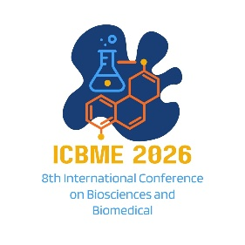

EXTENDED ABSTRACT TITLE

First Author¹, Second Author*² and Third Author³ (Full Name)

^{1, 2} Authors’ Department, Institute, City, COUNTRY.
(E-mail: firstauthorsname@aaaa.bbb, *secondauthorsname@aaaa.bbb)
³ Author’s Department, Institute, City, COUNTRY.
(E-mail: thirdauthorsname@aaaa.bbb)

ABSTRACT
The abstract should be typed in single-spaced in 10-points Times New Roman and not be more than 200 words. The abstract should not only indicate the subject and scope of the paper but also summarize the author’s conclusion. Structured abstract must be a brief, comprehensive summary of the contents of the article. It allows readers to survey the contents of an article quickly. An abstract summarizes the major aspects of a paper. It should succinctly summarize the purpose of the paper, the methods used, the major results, and conclusions.
Keywords: Keyword 1, Keyword 2, Keyword 3 (Min 3 Keywords & Max 5 Keywords)

INTRODUCTION
In this section, the author should address the following information: background, problems, and objectives of the research.

This is a template document that contains the format of an extended abstract for ICBME 2026. All submissions should strictly follow this format to ensure a consistent, high-quality appearance. The author can download the template from the conference website (https://utmspace.edu.my/icbme2026/). The easiest way to format your paper exactly like this template document is simply to replace the content with your own material.

The author should follow the following guidelines. The extended abstract should be written in MS Word format in single-spaced in 12-point Times New Roman except for abstract. Do not indent the text paragraphs. Each paragraph must be a single-spacing separated (Click icon ‘¶’ at the Home Tools). The in-text citation of the manuscript should be in numbered (Vancouver) with a square bracket ‘[]’only.

Authors are requested to submit the extended abstracts in electronic form (MS-Word) via our Online Submission. Please ensure the extended abstract has a minimum of 2 pages and a maximum of 3 pages in length, excluding the references. The pages should not be numbered. The incorrect formats may result in your abstract being returned to you by e-mail. The scientific committee will select the contributions for oral and poster presentations.

A digital version of the ICBME 2026 Proceedings will be published on the conference website. Only selected submissions will be invited to be extended into full papers for publishing in SCOPUS/ERA/WOS indexed journals or periodicals of the participants’ choice.

METHODOLOGY
In this section, the author should concisely describe and justify the research design choices, including methodological approach and limitations, sampling selection, materials, tools and instruments, data collection and analysis methods.

RESULTS AND DISCUSSION
In this section, the author should address the following information, which includes findings and discussion. Please observe Figure 1 and Table 1 to include the figure and table in the extended abstract, respectively. A figure should be inserted as shown below and referenced in the text.

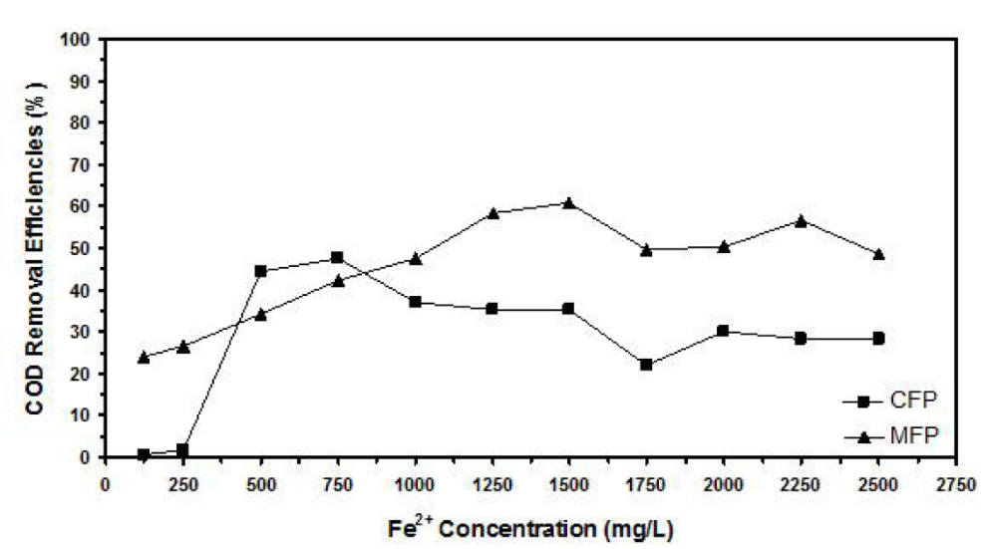
Figure 1. Example of figure for the extended abstract.

A table should be inserted like the one below and referred in the text. Please avoid vertical rules and shading in table cells.

Table 1. Example of a table for the extended abstract
Contents of Table
Xxx | Xxx xxxx

CONCLUSION
The conclusion is intended to help the reader understand why your research should matter to them after they have finished reading the paper. A conclusion is not merely a summary of the main topics covered or a re-statement of your research problem but a synthesis of key points and, if applicable, where you recommend new areas for future research.

Acknowledgment: The authors would like to express their appreciation for the support of the sponsors with Project No xxxx.

REFERENCES (Numbered, Vancouver Style)
- Author. Title. Journal. Year; Volume (Issue): Pages. (Journal Article)
- Author. Title. Conference Name; Date; Conference Location. Place Published: Publisher; Year Published. (Conference Papers)
- Author. Title. Conference Name; Year of Conference Date; Conference Location. Place Published: Publisher; Year Published. (Conference Proceedings)
- Schwartz, M. Title. Edition. Series editors. Place Published: Publisher; Year Date. Number of Pages. (Book)
- Author. Title. In: Editor’name, editor. Book Title. Series Title. Volume. Edition. Place Published: Publisher, Year. Pages. (Book Section)
- Author. Title [Thesis Type]. Place Published: University; Year. (Thesis)

